

PROJECT REPORT
Cover Page

Digital Literacy Project Portfolio

CSE0001: Digital Literacy

Submitted by:
- Name: Varad Shirish Jadhav
- Registration Number: 25BAI10629
- Branch: AIML (B.Tech.)
- Year: First Year

Submitted to:
- Course Instructor: Dr. Kannan
- Institution: VIT Bhopal University
Introduction :-

- In today’s technology-driven world, digital literacy has become an essential skill for students. It involves the ability to use digital tools effectively, communicate professionally online, and stay safe from cyber threats. As a Student Digital Ambassador, my role is to help peers understand and apply these skills in their academic and personal lives.

- This project focuses on building a Digital Literacy Portfolio through five practical tasks, including infographic creation, developing professional profiles, exploring coding platforms, writing formal emails, and studying cybercrime awareness. Each task provided hands-on experience with real-world tools and platforms.

- Through this project, I learned the importance of maintaining a professional digital presence, using online tools efficiently, and being aware of online risks. These skills are essential not only for academic success but also for future career opportunities.

Task 1 – Digital Literacy

- Infographic For this task, I created a digital literacy awareness infographic using Canva. The infographic explains what digital literacy is and why it is important for students. It includes key topics such as safe internet practices, useful digital tools, and maintaining a professional online presence.

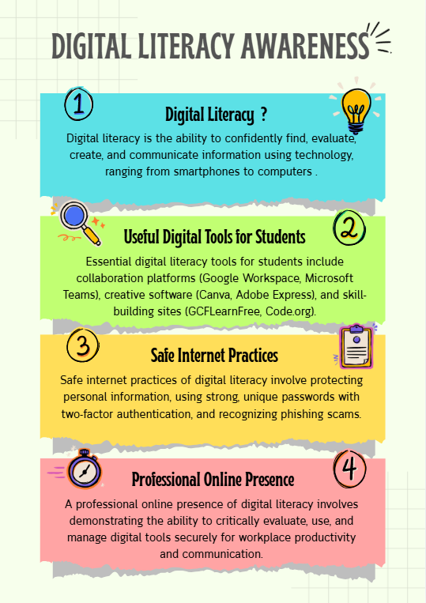
- I used simple icons, headings, and short descriptions to make the design visually appealing and easy to understand. The goal was to ensure that anyone viewing the infographic could quickly grasp the key ideas.

- One challenge I faced was balancing text and visuals. Initially, the design looked overcrowded, so I had to simplify the content and focus only on important points. This helped me improve my design and presentation skills.

- Overall, this task helped me learn how to present information creatively and effectively.

Task 2 – Student Digital Portfolio

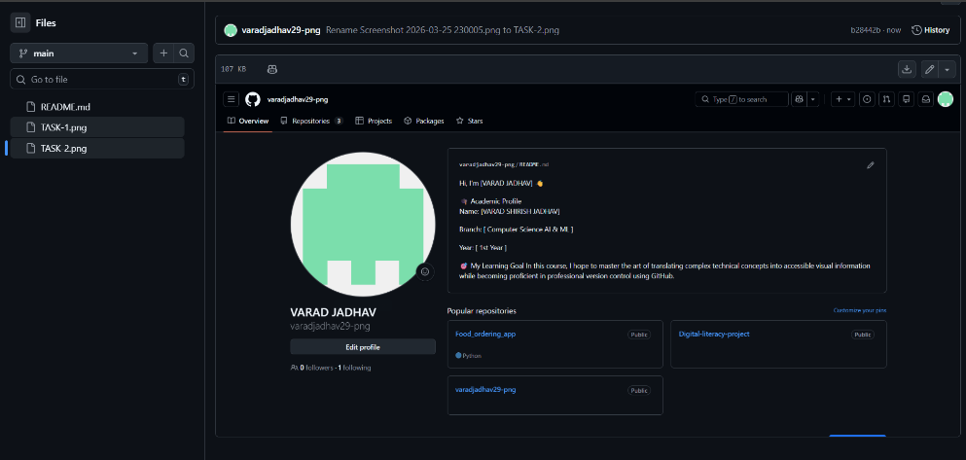
- For building my digital portfolio, I selected GitHub, LinkedIn, and Kaggle as they are highly relevant for a student in the AI/ML field. GitHub is mainly used for hosting and managing code repositories. I created my profile README including my name, branch, and learning goals, which will help me showcase my projects and coding skills over time.
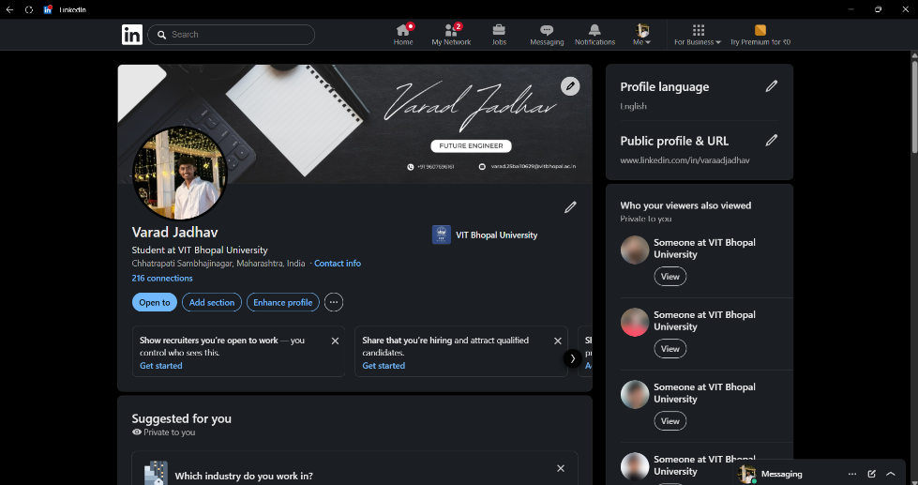
- LinkedIn is a professional networking platform where I added my education details, including my B.Tech. in AIML at VIT Bhopal. It will help me connect with professionals, explore internships, and build my personal brand.
- Kaggle is widely used for data science practice, competitions, and datasets. I plan to use it to improve my machine learning skills by working on real-world datasets and participating in competitions.
- Over the next four years, I aim to regularly update my GitHub with projects, stay active on LinkedIn for networking opportunities, an use Kaggle to strengthen my practical knowledge in data science and AI.
Task 3 – Coding & Collaboration Platforms
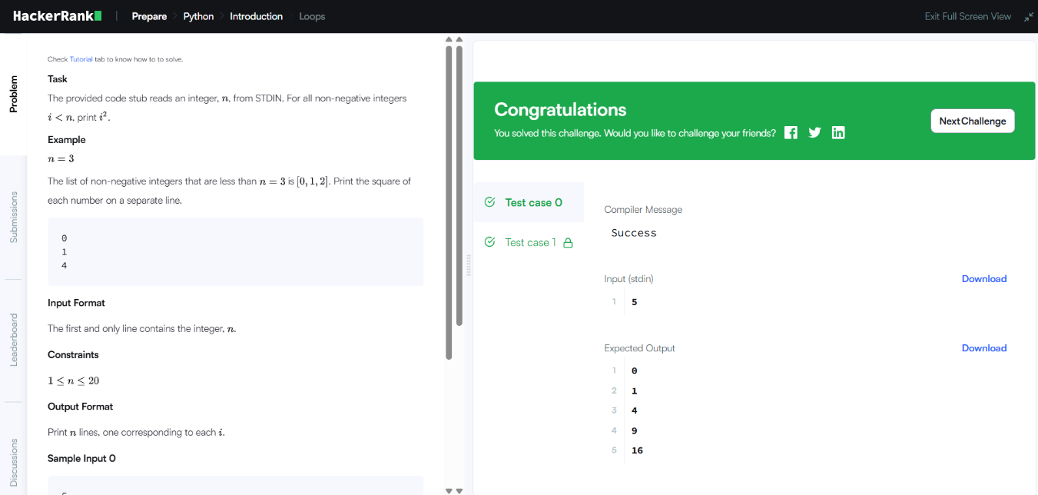
- For this task, I used HackerRank to complete a beginner-level coding challenge. This helped me understand basic programming concepts and improve my logical thinking.

- I also created a Google Form as a Digital Literacy Awareness Quiz. The form includes five questions such as multiple-choice and short-answer questions. It can be used to test students’ understanding of digital literacy.

- Creating the form helped me learn how to collect responses and analyze data using Google Sheets. This is useful for surveys,
feedback collection, and academic purposes.

- These tools are very helpful for students. HackerRank improves coding skills, while Google Forms supports collaboration and data collection. Both will be useful throughout my academic journey.

Task 4 – Email Etiquette & Communication

- In this task, I wrote two professional emails—one requesting an assignment extension and another applying for an internship. I followed proper email etiquette, including clear subject lines, polite greetings, structured content, and professional closing.

- I also created a checklist of social media do’s and don’ts to promote responsible online behaviour among students.

- Poor digital communication can lead to misunderstandings and create a negative impression. For example, sending informal or unclear emails to professors can affect credibility.

- This can be avoided by maintaining professionalism and clarity in communication. This task helped me understand the importance of proper communication in academic and professional environments.

Task 5 – Cybercrime Awareness

- For this task, I studied phishing as a cybercrime. Phishing involves tricking users into sharing sensitive information through fake emails or websites.
- What surprised me most was how realistic phishing attacks can appear, making them difficult to identify. Many people fall victim due to lack of awareness.
- After completing this task, I will be more cautious while clicking on links and will always verify the authenticity of emails and websites before sharing any personal information.
- This task helped me understand the importance of cybersecurity and safe internet practices.

Conclusion
- This project helped me develop essential digital literacy skills such as creating visual content, building a professional online presence, using collaboration tools, and understanding cybersecurity.

- Each task provided practical knowledge and improved my confidence in using digital platforms. These skills will be highly useful in my academic journey and future career.

- Overall, this project was a valuable experience that highlighted the importance of responsible and effective use of digital technologies.

----------------------------------------------------------------------------------------------------------

References

- Canva – https://www.canva.com

- GitHub – https://github.com

- LinkedIn – https://www.linkedin.com

- HackerRank – https://www.hackerrank.com

- Google Forms – https://forms.google.com

- National Cyber Crime Portal – https://cybercrime.gov.in

----------------------------------------------------------------------------------------------------------

